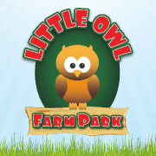
Little Owl Farm Park Work Experience / Voluntary Work Placement Application

Full Name: Age:

Contact Number:

Contact Email Address:

Why do you wish to gain experience with Little Owl Farm Park?

Days/Dates you are Available (Please see details on the website for times etc.):

Department interested in:

Previous Employment/Experience History Brief Overview (please put your most current first)
Employer | Job Title & Duties | Reason for Leaving | Dates
Education Brief Overview (Please put your most current first)
School/College/Uni | Subjects, Grades & Qualifications |  | Dates
For Little Owl Farm Park to complete (circle):

TRIAL OFFERED OR NO AVAILABILITY (If Trial Offered) APPROVED OR DENIED

