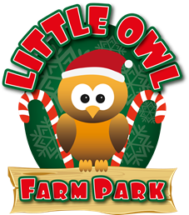 | LITTLE OWL FARM PARK  MINI CHRISTMAS MARKET  STALL HIRE FORM OF INTEREST  FRIDAY, 4TH DECEMBER – SUNDAY, 6TH DECEMBER 2020

Thank you for your interest in hiring a stall from us at our first ever Mini Christmas Market! Please complete the form below to register your interest. We will then get back to you as soon as possible with further details. Please do bare in mind that if we have a high number of applications, there may be a delay in getting back to you. Thank you for your interest and thank you for your patience.

Key Information

- Our Mini Christmas Market will be running from the 4th December to the 6th December, if there is a high level of interest, we may add additional dates
- Stalls will be open from 12pm – 4pm & 5pm – 9pm each day
- Stall hire for the 3 days will be £150.00
- Stall areas will be 6ft by 6ft, and located in various areas around the farm park
- The stall types to hire will be; Arts & Crafts, Food & Drink (for home consumption), Gifts, Hot Food & Drink (on site consumption)
- If an electricity supply is needed, extra charges may be required
- A deposit payment of £50.00 will be due by the 23rd October and the remaining amount will be due by 16th November. Please note, if the event has to be cancelled due to increased restrictions, you will receive a full refund.

Contact Name
Organisation Name (if applicable)
Address

Postcode
Telephone
Website
Email
Business Status (e.g. Sole Trader, Limited Company)
Stall Type

Once completed, please return this form to Victoria Howell via email to info@littleowlfarmpark.co.uk

